A1106-AM,S-**Peru-**Chavín**-Jaguar with Crenelated crown-Granite-400 BCE**

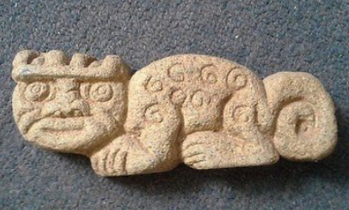

Fig. 1. Chavín**-Jaguar with Crenelated crown-Granite-400 BCE**

**Formal Label: Peru-**Chavín**-Jaguar with Crenelated crown-Granite-400 BCE**

**Accession Number: A1106**

**Display Description:** The jaguar had a particular significance in many pre-Columbian cultures and most especially in the Chavín culture.

The Chavín developed their culture in the Mosna Valley at the confluence of the Mosna and Huachecsa near Chavín de Huántar at 3,150 m (10,330 ft) above sea level which encompasses three ecozones: the *quechua* (montane valleys), the *suni* (scrubs and agriculture), and the *puna* (mountaintop grassland) (Burger 2008; Pulgar 1979). In the Urabarriu period (900-500 BCE) the Chavín lived in dispersed settlements and depended on hunting and gathering as well as some primitive maize agriculture.

During this period a Jaguar Cult developed that revered the powers of the feline mostly for hunting. Then, in one century (500-400 BCE), the dispersed settlements coalesced around the ceremonial center of Chavín de Huántar. Hunting diminished as the domestication of llamas and maize developed and trade expanded. The Jaguar Cult became less associated with hunting and more associated with a cult of élites.

**LC Classification:** F3429.1.C48

**Date or Time Horizon:** 900 BCE–250 BCE

**Geographical Area:** coastal Peru from Chan Chan to Pachacamac

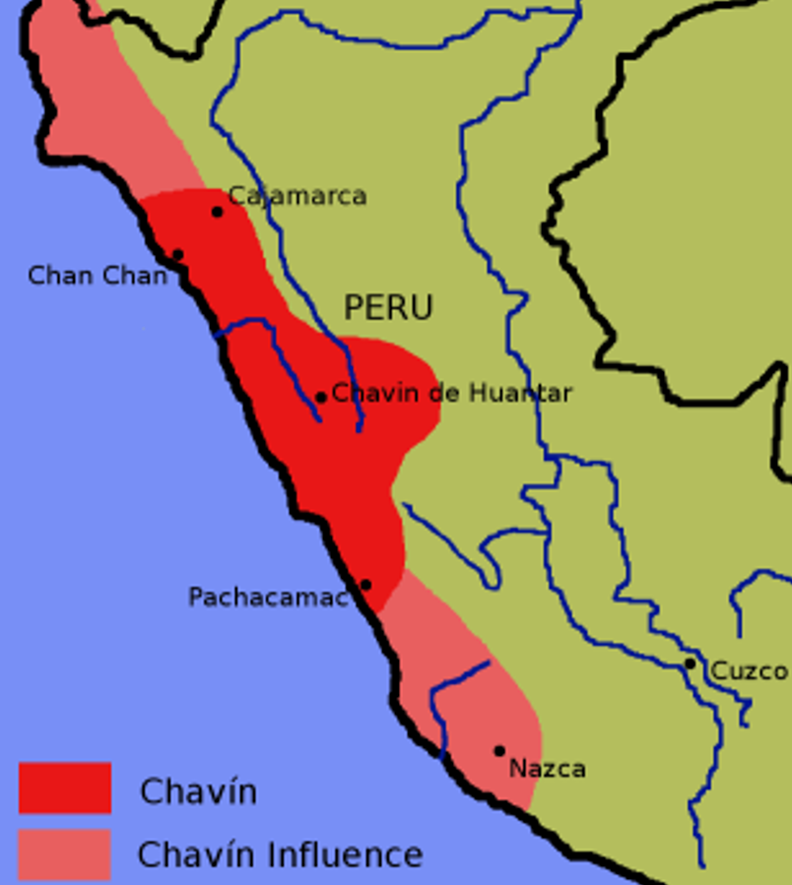

Fig. 2. Map: The extent of the influence of the Chavín de culture. Created by [en:User:Zenyu](https://en.wikipedia.org/wiki/User:Zenyu) and released to {{PD}} by Zenyu, source.

GPS: Chavín de Huántar, [9°35′34″S 77°10′42″W](https://tools.wmflabs.org/geohack/geohack.php?pagename=Chav%C3%ADn_de_Huantar&params=9_35_34_S_77_10_42_W_type:landmark);

**Cultural Affiliation:** Chavin

**Medium:** Granite

**Dimensions: L 6 in**  
**Weight: 398 gm; 14 oz**

**Provenance: old Peruvian collection**

**Condition:** Original

**Discussion:**

In the final stage of the Chavín culture, the Jarabarriu Period (400-250 BCE), a dramatic increase in population occurred following vastly increased agricultural development. During this period the Jaguar Cult became a cult of élites centered on a version of shamanism that revered the qualities of the jaguar. During this period the psychotropic San Pedro cactus may have been used in the Jaguar Cult, which was an idealization of an identity that became a means of acquiring power. While those who were accepted into the Jaguar Cult presumably represented the embodiment of a warrior’s skill and with an emphasis on defending the expansion of Chavín territory, there is little evidence that this role was actually employed. While the jaguar was seen as the perfect animal, in complete symbiosis with nature, able to subdue any prey, the ideal warrior was seen to merge with these jaguar skills and to become one with him setting an example to the community. In the world-view of the Chavín of the Jarabarriu Period, the warrior became more of a social and less of a military ideal.

This granite plaque of the jaguar suggests that it is evidence of the last stage of the Chavín culture. During this period, asymmetrical power was hoarded by the Jaguar Cult élites, which is reflected in the extensive remodeling of the Chavín de Huántar temple (Kembel and Rick 2004). Perhaps this granite jaguar was emplaced in one of these renovations as a symbol of the emerging rulers. With this emphasis on an élite warrior cult, ironically, warfare does not seem to have been a significant factor in Chavín culture, since basic defensive structures in Chavín centers are missing, and Chavín art does not depict warriors in battle. They are depicted as an élite social class to which this jaguar plaque alludes.

**References:**

Burger, Richard L. 2008. “Chavín de Huántar and its Sphere of Influence.” In *Handbook of South American Archeology*, edited by H. Silverman and W. Isbell. New York: Springer, pp. 681–706.

Burger, Richard L., and Nikolaas J. Van Der Merwe (1990). "Maize and the Origin of Highland Chavín Civilization: An Isotopic Perspective", *American Anthropologist* 92(1):85–95.

Kembel, Silvia Rodriquez and John W. Rick. 2004. “Building Authority at Chavín de Huántar: Models of Social Organization and Development in the Initial Period and Early Horizon.” In Helaine Silverman, ed., *Andean Archaeology*. Malden, Massachusetts: Blackwell Publishers, pp. 51-76.

Pulgar Vidal, Javier. 1979. *Geografía del Perú; Las Ocho Regiones Naturales del Perú.* Edit. Universo S.A., Lima 1979.